**Critical Thinking 3**

Alastair A. Ohde

Colorado State University Global

CSC 372-1

Vanessa Cooper

May 4, 2025

import javax.swing.*;

import java.awt.*;

import java.awt.event.*;

import java.io.*;

import java.util.Random;

public class GreenInterface {

    private JFrame frame;

    private JTextArea textBox;  //Text Area of frame

    public GreenInterface() {

        frame = new JFrame("User Interface Example");

        frame.setDefaultCloseOperation(JFrame.EXIT_ON_CLOSE);

        frame.setSize(400, 300);

        frame.setLayout(new BorderLayout());

        //Set the size and type of frame

        JMenuBar menuBar = new JMenuBar();

        JMenu fileMenu = new JMenu("File");

        JMenuItem showDateTimeItem = new JMenuItem("Show Date and Time");

        JMenuItem saveToFileItem = new JMenuItem("Save to File");

        JMenuItem changeBackgroundColorItem = new JMenuItem("Change Background Color");

        JMenuItem exitItem = new JMenuItem("Exit");

        //Set the 4 options of the filemenu

        showDateTimeItem.addActionListener(new ActionListener() {

            public void actionPerformed(ActionEvent e) {

                showDateTime();

            }

        });

        saveToFileItem.addActionListener(new ActionListener() {

            public void actionPerformed(ActionEvent e) {

                saveToFile();

            }

        });

        changeBackgroundColorItem.addActionListener(new ActionListener() {

            public void actionPerformed(ActionEvent e) {

                changeBackgroundColor();

            }

        });

        exitItem.addActionListener(new ActionListener() {

            public void actionPerformed(ActionEvent e) {

                System.exit(0);

            }

        });

        //These 4 groups of code allow the 4 options to perform actions

        fileMenu.add(showDateTimeItem);

        fileMenu.add(saveToFileItem);

        fileMenu.add(changeBackgroundColorItem);

        fileMenu.add(exitItem);

        //Adds the 4 options to the file menu

        menuBar.add(fileMenu);  //Adds the filemenu to the menubar

        frame.setJMenuBar(menuBar);  //sets the menubar

        textBox = new JTextArea();

        frame.add(new JScrollPane(textBox), BorderLayout.CENTER);

        //Allows for scrolling if all info in box cannot be seen

        frame.setVisible(true);  //Allows you to see the frame

    }

    private void showDateTime() {

        String dateTime = new java.util.Date().toString();

        textBox.append(dateTime + "\n");

        //This will display date and time

    }

    private void saveToFile() {

        String content = textBox.getText();

        try (BufferedWriter writer = new BufferedWriter(new FileWriter("log.txt"))) {

            writer.write(content);

        } catch (IOException e) {

            e.printStackTrace();

        //This will save to file

        }

    }

    private void changeBackgroundColor() {

        Random random = new Random();

        int Gvalue = random.nextInt(256);

        Color Rgreen = new Color(0,Gvalue,0);

        frame.getContentPane().setBackground(Rgreen);

        //This will change color of background

    }

    public static void main(String[] args) {

        SwingUtilities.invokeLater(new Runnable() {

            public void run() {

                new GreenInterface();

        //This schedules a new GreenInterface - the public class - after all other processes have been completed

            }

        });

    }

}

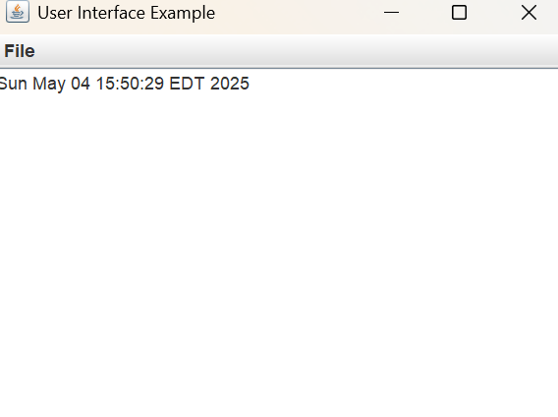

https://github.com/Ebberous/CSC320-1-Critical-Thinking